Strasbourg Write a Story Competition

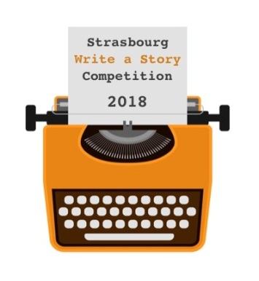
The competition committee is gearing up for the sixth year so:
Once again it’s time to ‘Free the writer within!’
Entries will be accepted between 1st December 2018 and 15th February 2019.
- Our aim, as in previous years, is to encourage the creative spirit and to promote the English language in the region;
- Everyone is invited to compete, regardless of age, nationality or native language;
- There are junior and adult categories (17 and under/18 and over), for both native and non-native speakers;
- You can write about any subject that inspires you in a story of up to 1200 words;
- The entry fee is 7€. We are delighted to offer free entry to junior writers (under 18 category);
- One entry is allowed per person;
- The annual award ceremony will be held on 27th April to announce the winners and to present them with a copy of the published book containing their stories.
For more information and to sign up to our free creative writing workshops visit our website: Strasbourg write a story.
Further details including how to enter and all the competition rules are available at: www.sxb-write-a-story.org
Email: info@sxb-write-a-story.org
Or chat with us at: www.facebook.com/sxb.write.a.story

